YOU NEED DISCIPLINE
WHY : po co ja sie pierdole ?
-
- lepszy start do NY i do Singapuru, to jest moj bilet tam...
- bede mial wieksze oczekiwania finansowe. wieksza pensje.
- bede lepszy niz fdp's
- mozesz liczyc tylko na siebie, placisz za siebie, no body rien à

Living without discipline:
- your life is limited
- You will build nothing,
- you will never end up where you want to be
- you will be unreliable, unable to plan, be a floater in life, align with your own resistance
- Fail to delay instant gratification in face of short-term temptation
- You will have ruined every relationship around you
- You will be at mercy of everything around you, including your own mind, Emotions and body
Painfull is with aligne;ent what you really want
Passive way of being vs active way of being
you are not at mercy of the other people

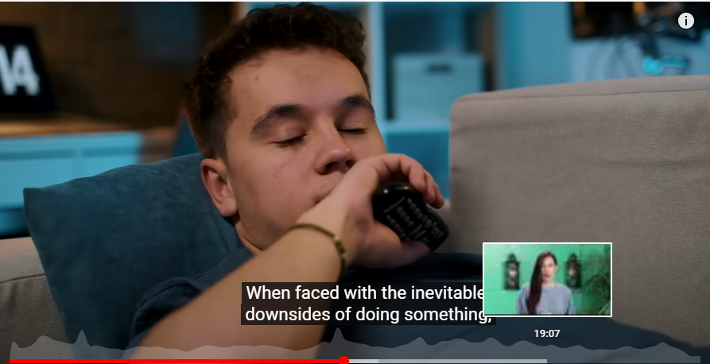 | 